**Evaluation metrics for Regression**

1. ***Root Mean Squared Error***

[*Root mean squared error*](https://en.wikipedia.org/wiki/Root-mean-square_deviation) is the most popular metrics used in Regression problems.RMSE is defined by the standard deviation of prediction errors. These prediction errors are some times called Residuals. Residuals are basically the measurement of the distance of data points from the Regression line.

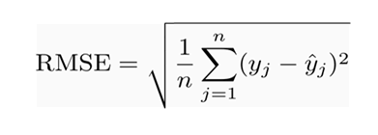

**Where**:

* Σ = [summation](https://www.statisticshowto.datasciencecentral.com/summation/)(“add up”)
* (yi— yj)Sup>2 = differences, squared
* N = [sample size](https://www.statisticshowto.datasciencecentral.com/probability-and-statistics/find-sample-size/)

Putting it in a simple way RMSE tells us how well the concentration of data points around the regression line. With RMSE it is assumed residuals are unbiased and follow a normal distribution. Below are some interesting points related to Root mean squared error.

* RMSE works efficiently when we are dealing with a large volume of data points. Hence error reconstruction becomes more reliable.
* As per RMSE mathematical formula the “square root” shows a large number deviation.
* Before using RMSE be sure that there are no outliers in the dataset because RMSE is heavily influenced by outliers.
* Root mean squared error has higher weightage and it also penalizes errors as compared to other evaluation metrics.

***2. Mean Absolute Error***

The Average taken between the original values and predicted values is called [*Mean Absolute Error*](https://scikit-learn.org/stable/modules/generated/sklearn.metrics.mean_absolute_error.html#sklearn.metrics.mean_absolute_error). It also measures the average magnitude of error i.e.how far the predictions from the actual output. Moreover, MAE does not provide us any direction of error i.e. whether we are overfitting the data or underfitting the data.

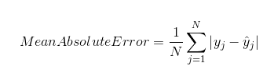

***3. Mean Squared Error***

There is a minor difference between [MSE](https://scikit-learn.org/stable/modules/generated/sklearn.metrics.mean_squared_error.html#sklearn.metrics.mean_squared_error) and MAE. Deviation comes in MSE takes the average of the **square**of the difference between the original values and the predicted values. In MSE computation of gradient becomes easier than MAE which requires computational tools in order to compute gradients.

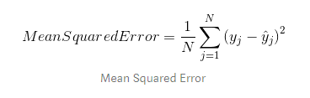

Mean Squared Error is good to use when the target column is normally distributed around the mean value. Mean squared error comes into the picture when outliers are present in our dataset and it becomes necessary to penalize them.

***4. R Squared/Adjusted R Squared***

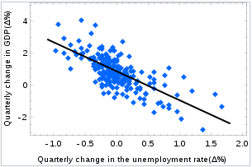

source:<https://blog.minitab.com/blog/adventures-in-statistics-2/multiple-regession-analysis-use-adjusted-r-squared-and-predicted-r-squared-to-include-the-correct-number-of-variables>

[*R squared*](https://scikit-learn.org/stable/modules/generated/sklearn.metrics.r2_score.html#sklearn.metrics.r2_score) is a statistical measure of how close the data point is fitted to the regression line. It is also known as the coefficient of determination.R-Squared is defined by the explained variation divided by total variation that is explained by the linear model.

R squared value always lies between 0% to 100 % hence 0% indicates none of the variability of the response data around its mean and 100 % shows model explains all the variability of the response data around its mean. This clearly means a higher R square value model perfect your model is.

R-squared = Explained variation / Total variation

On the other hand, R squared *cannot* determine whether the coefficient estimates and predictions are biased. So Adjusted R squared come into the picture, It has explanatory power for regression models that has a different number of predictors Putting it in a simple way Adjusted R squared basically explains regression models having multiple independent variables or predictors.

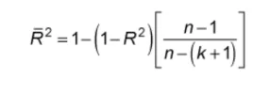

The adjusted R-squared is a modified version of R-squared that has been adjusted for the number of predictors in the model. It increases only if the new term improves the model more than would be expected by chance. Adjusted R-squared is not a typical model for comparing non-linear models, but multiple linear regressions.